NATIONAL UNIVERSITY OF TECHNOLOGY
ICAT Project

ICAT Project (Navbot: Real-time Autonomous
Navigation Vehicles)
Department | Registration Number/Name | Semester/Section
CEN | Javad Sohail Dar  (F24604001)  Muhammad Hamzah Iqbal  (F24604018)  Ismail  (F24604026)  Rohan Kumar  (F24604054)  Atta-ul-mustafa  (F24604013)  Tariq Khan  (F24604060)  Abdullah waheed)  (F24604043)  Muhammad Fahad Bhatti  (F24604035) | 1/ICAT Project
Date | Instructor’s Name | Instructor’s Signature
4/2/2025 | Lec. Faria Tasneem Sheikh

Introduction
The Smart Car System is an advanced technological project designed to improve remote vehicle management through GPS tracking and ESP server control. Unlike previous implementations that relied on manual or voice-controlled operation, this system leverages modern IoT capabilities to provide seamless and efficient navigation. By incorporating the ESP32-CAM microcontroller, the project ensures enhanced performance, real-time location updates, and visual monitoring, which were previously unavailable in conventional robotic car models.
This smart car is equipped with a GPS module to determine its precise location, an ESP32-CAM to facilitate wireless communication, and an ESP server to remotely manage vehicle functions. The system not only allows users to control the car's movement remotely but also enables real-time tracking on an interactive map, offering a significant improvement over traditional remote-controlled or voice-command-driven vehicles.
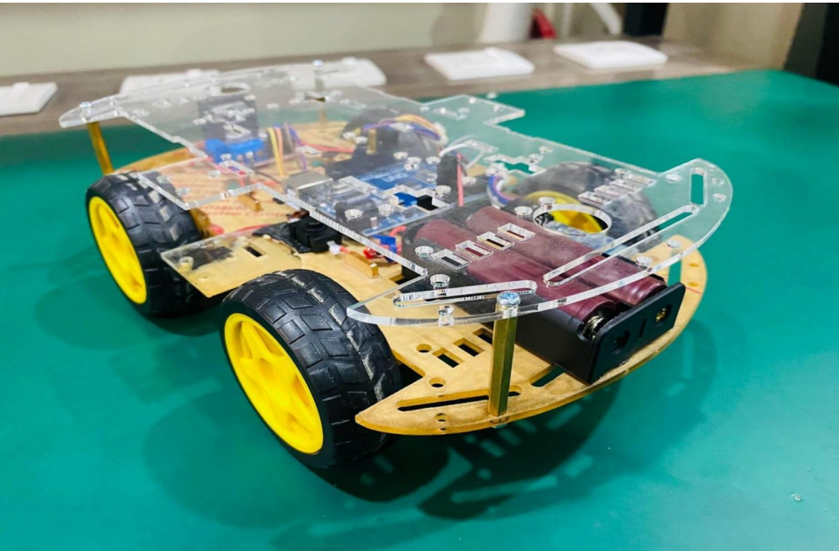
The integration of these components provides a robust solution for various applications, such as automated vehicle management, security patrols, and smart transportation. With the ability to visualize exact locations through an intuitive web interface, users can efficiently monitor and manage their vehicles without requiring direct physical interaction. This report explores the design, development, and implementation of this cutting-edge system, highlighting the significant improvements over previous iterations and addressing key challenges in remote vehicle control.
Description
The GPS-enabled robot car using ESP32-CAM is an advanced IoT-based system designed for real-time location tracking, remote monitoring, and control. This project replaces conventional remote-controlled vehicles with a smarter, internet-enabled alternative that provides an interactive user experience. The vehicle is equipped with an ESP32-CAM microcontroller, a GPS module for precise location tracking, and an ESP Server to facilitate remote access through a web-based interface.
Key Features of the System
- GPS-Enabled Navigation:
  - The robot car is capable of tracking its location in real time using the NEO-6M GPS module.
  - The collected GPS data is processed and displayed on an interactive map through the ESP Server.
- ESP32-CAM for Live Video Streaming:
  - The ESP32-CAM module provides live video streaming to enhance the user’s ability to monitor and navigate the car remotely.
  - The video feed is accessible via the web interface hosted on the ESP Server.
- Web-Based Remote Control:
  - Unlike conventional Bluetooth or RF-controlled systems, this vehicle is controlled through an ESP Server, allowing commands to be sent from any device with a web browser.
  - The user can access movement controls and view GPS coordinates in real time.
- ESP Server Integration:
  - The ESP Server acts as the central hub for data exchange, processing user commands and updating the live feed.
  - It ensures seamless interaction between the hardware components and the remote user.
- Power-Efficient and Compact Design:
  - The car is powered by a 7.4V battery, optimized for efficient energy consumption.
  - Low power usage allows extended operation time before recharging is required.

6. Multi-Purpose Application:
  - The system is ideal for applications such as security patrolling, surveillance, automated deliveries, and IoT-based automation.
  - It can be further enhanced by integrating AI-based object detection and obstacle avoidance.
System Workflow
- The ESP32-CAM module initializes and establishes a connection with the ESP Server.
- The GPS module continuously updates the real-time coordinates of the vehicle.
- The live video feed and GPS location are displayed on the web interface.
- The user sends movement commands via the web-based control panel.
- The ESP32 processes these commands and controls the motors via the L298N motor driver.
- The car moves in the desired direction while updating its position dynamically.
Methodology
The development of the GPS-enabled robot car follows a structured approach, ensuring systematic integration of hardware and software components. The methodology is divided into multiple phases, including hardware assembly, firmware development, server setup, and testing.
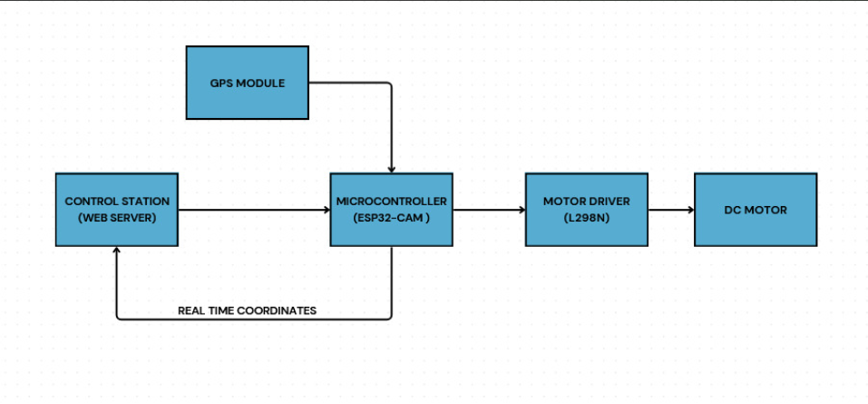

Phase 1: Hardware Setup
- Component Selection and Integration
  - ESP32-CAM is chosen as the main controller for its Wi-Fi capability and video streaming support.
  - The NEO-6M GPS module is integrated to provide real-time location tracking.
  - The L298N motor driver is used to control the movement of the robot car.
  - A 7.4V lithium-ion battery is used to power all components efficiently.
- Circuit Design and Wiring
  - All components are connected following a well-defined circuit schematic.
  - Proper voltage levels and connections are ensured to prevent power surges or damage.
  - The GPS module is configured to communicate with the ESP32 through UART.
Phase 2: Software Development
- ESP32 Firmware Development
  - The ESP32 is programmed using Arduino IDE, incorporating libraries for GPS data parsing and motor control.
  - The firmware handles user inputs from the web interface and executes movement commands accordingly.
  - Error handling and data validation mechanisms are implemented to improve reliability.
- ESP Server Setup
  - A lightweight web server is hosted on the ESP32 to allow remote access.
  - The web interface is developed using HTML, JavaScript, and AJAX for real-time updates.
  - The ESP32 continuously transmits GPS coordinates to the server, which updates the live map.
Phase 3: Testing and Optimization
- Connectivity and Communication Testing
  - The ESP32 is tested for stable Wi-Fi connectivity and server responsiveness.
  - GPS accuracy is verified by comparing received coordinates with known locations.
- Motor Control and Navigation Testing
  - The robot car is tested for movement precision, including forward, backward, left, and right turns.
  - Response time between command execution and movement is measured.
- Power Consumption Optimization
  - The system's power consumption is analyzed, and low-power modes are implemented where applicable.
  - Battery runtime is tested under different conditions to estimate operational efficiency
- Final Integration
  - All hardware and software components are combined into a complete system.
  - Additional features, such as obstacle detection, may be added for future enhancements.
- Field Testing
  - The robot car is tested in real-world environments to evaluate performance under different conditions.
  - GPS tracking, remote control, and live streaming are assessed in both indoor and outdoor settings.
Working Principle
1. System Overview
The robotic car is powered by the ESP32-CAM, which acts as the primary microcontroller, handling both web-based control and GPS tracking functionalities. The vehicle’s position is continuously monitored through an onboard GPS module, and users can control movement via a web interface hosted on the ESP server. The real-time location is displayed on an interactive map, providing an intuitive and accurate tracking system.
2. ESP32-CAM Control and Web Interface
- The ESP32-CAM acts as the system’s brain, processing commands from the web server and translating them into motor control signals.
- A web interface is hosted on the ESP server, allowing users to remotely operate the vehicle through any internet-enabled device.
- The interface includes options for directional movement, speed control, and real-time status monitoring.

3. GPS Tracking and Location Mapping
- The NEO-6M GPS module continuously fetches latitude and longitude data.
- The ESP32-CAM processes the GPS data and sends it to the ESP server, updating the vehicle’s position in real-time.
- The location is displayed on a Google Maps-based web interface, ensuring that users can monitor the vehicle’s movement remotely.
- The system allows real-time tracking and historical route monitoring.
4. Motor Driver and Movement Control
- The L298N motor driver regulates power delivery to the motors based on control commands received from the ESP32-CAM.
- The system enables smooth and responsive directional control, including forward, backward, left, and right movements.
- PWM signals are used to control the speed of the vehicle.
5. Communication and Data Flow
- The user accesses the ESP32-CAM’s web interface from a smartphone or computer.
- Commands are sent over Wi-Fi to the ESP server, where they are processed.
- The ESP32-CAM translates the commands into motor control signals and relays them to the L298N motor driver.
- Simultaneously, GPS coordinates are fetched and updated on the web-based map.
- The vehicle executes movement commands while continuously updating its location.
6. Safety and Error Handling
- If the GPS signal is lost, the system alerts the user via the web interface.
- A fail-safe mechanism ensures that the vehicle stops moving if communication with the ESP server is interrupted.
- Power monitoring is integrated to prevent sudden shutdowns due to battery depletion.
- Error logs are maintained for debugging and optimization.

7. Advantages and Applications
- Remote monitoring and control enhance security and usability.
- The system can be used for surveillance, patrol, and research purposes.
- Real-time tracking allows efficient fleet management and autonomous vehicle testing.

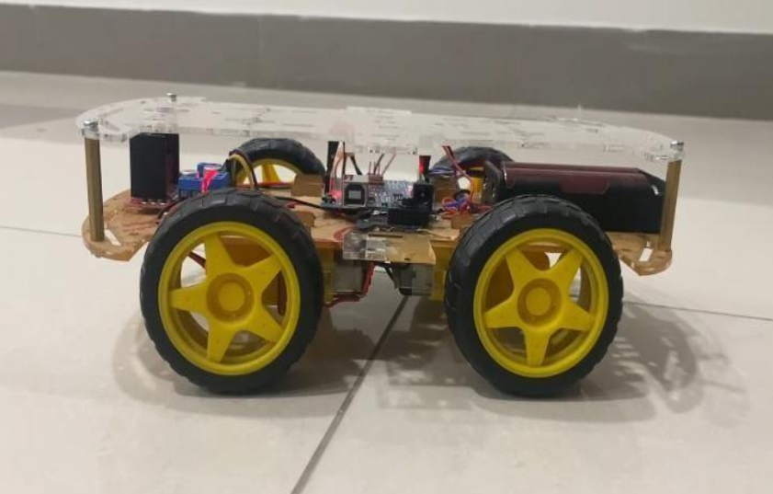

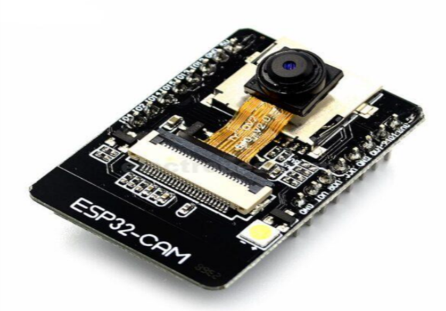
Components Description with Functionality
1. ESP32-CAM (Microcontroller and Web Server)
- Acts as the main processing unit, handling both control commands and GPS data.
- Hosts a web interface via the ESP server for remote control.
- Captures and transmits real-time video feed for additional monitoring.
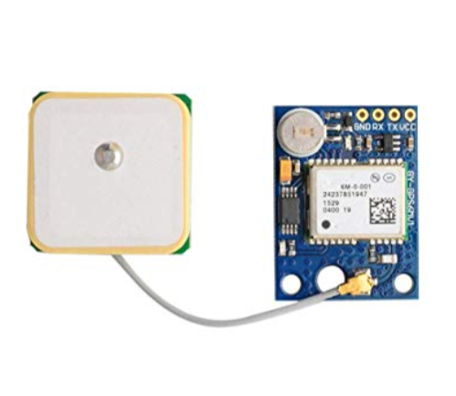
2. NEO-6M GPS Module (Real-Time Location Tracking)
- Continuously fetches latitude and longitude coordinates of the robotic car.
- Sends real-time location data to the ESP32-CAM.
- Ensures accurate tracking by integrating with Google Maps API on the web interface.
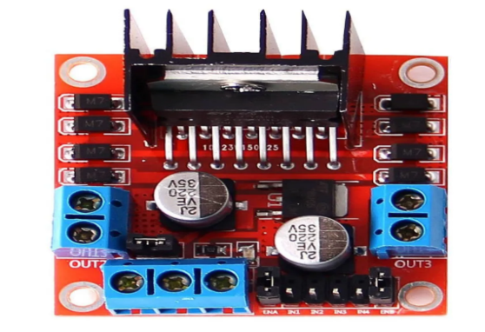
3. L298N Motor Driver (Motor Control Unit)
- Controls the power distribution to the DC motors.
- Receives control signals from the ESP32-CAM and adjusts the speed and direction of the vehicle.
- Uses PWM signals to regulate motor speed, ensuring smooth movement.

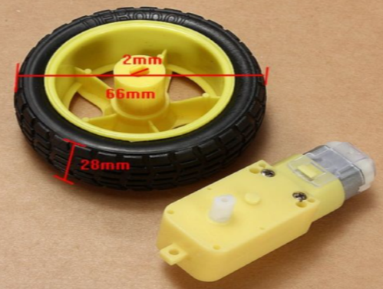
4. DC Motors (Robotic Car Propulsion System)
- Responsible for vehicle movement, powered through the L298N motor driver.
- Operates in forward, backward, left, and right directions based on control signals.

5. ESP Server (Remote Control and Communication)
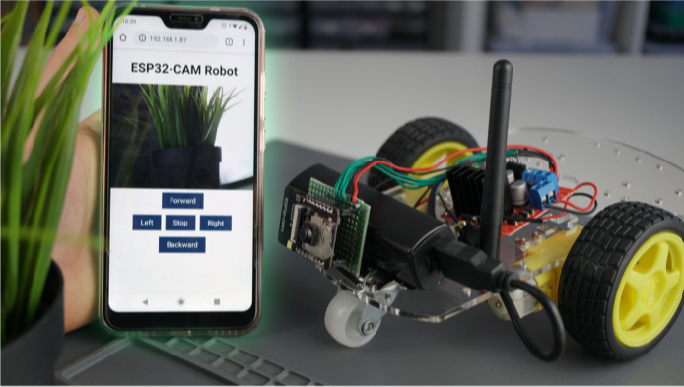
- Hosts the user interface, allowing control via a web page accessible through a smartphone or computer.
- Receives commands from the user and sends them to the ESP32-CAM for execution.
- Handles bidirectional communication, ensuring real-time feedback from the vehicle.

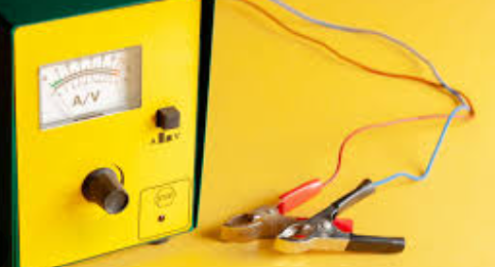
6 . Power Supply (Battery and Voltage Regulation)
- Provides the necessary power for all electronic components.
- Includes voltage regulators to ensure stable power delivery to ESP32-CAM, GPS module, and motor driver.
- Monitors power levels to prevent sudden shutdowns.

Source Code
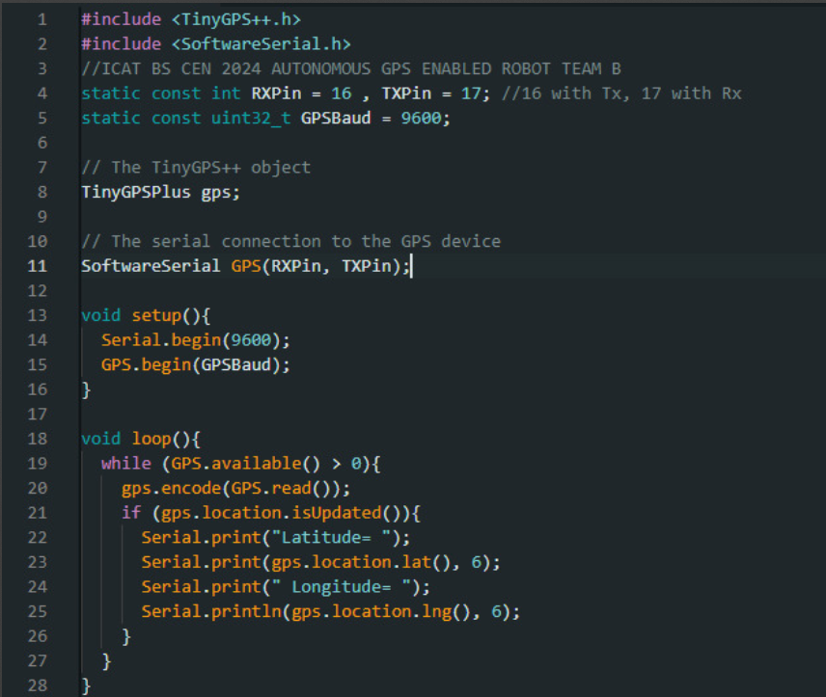

References
- TinyGPS++ Library Documentation: https://github.com/mikalhart/TinyGPSPlus
- ESP32-CAM Datasheet: https://www.espressif.com/en/products/socs/esp32
- L298N Motor Driver Specifications: https://www.handsontec.com/dataspecs/L298N%20Motor%20Driver.pdf
- Google Maps API Documentation: https://developers.google.com/maps/documentation
- Arduino IDE: https://www.arduino.cc/en/software
- Wi-Fi Networking Basics: https://www.cisco.com/c/en/us/solutions/enterprise-networks/what-is-wifi.html

Algorithm
1.Include Necessary Libraries
. Tiny GPS++: Handles the decoding of GPS data from NMEA sentences into usable information like latitude and longitude.
. Software Serial: Allows the use of additional serial communication on specified pins for the GPS module.
2.Define Constants
- RXPin (16): Pin used to receive data from the GPS module.
- TXPin (17): Pin used to transmit data to the GPS module.
- GPSBaud (9600): Communication speed for the GPS module.
3.Initialize Objects
. TinyGPSPlus gps: Processes GPS data for location updates.
. SoftwareSerial GPS: Creates a serial connection to communicate with the GPS module using RX and TX pins.
4.Setup Function
- Serial.begin(9600): Initializes USB serial communication at 9600 baud for data display on the serial monitor.
- GPS.begin(GPSBaud): Sets up the communication between the Arduino and GPS module at the defined baud rate (9600).
5.Main Loop
The loop function continuously checks for new GPS data and processes it.
Step 5.1: Check for GPS Data
- GPS.available(): Checks if the GPS module has sent any data.
- The while loop runs only if there is data available.
Step 5.2: Decode the Data
• GPS.read(): Reads one character at a time from the GPS module.
• gps.encode(): Parses the raw GPS data into meaningful information using the TinyGPS++ library.
Step 5.3: Check for New Location Updates
- gps.location.isUpdated(): Returns true if a new GPS location (latitude and longitude) is available.
Step 5.4: Retrieve and Print Location
- gps.location.lat(): Gets the latitude value.
- gps.location.lng(): Gets the longitude value.
- Serial.print() / Serial.println(): Outputs the latitude and longitude values to the serial monitor with six decimal places of precision.
Calculations
1. Power Consumption
To ensure the car operates efficiently, we calculate the total power requirements:
- ESP32-CAM: Consumes approximately 160-240 mA at 5V.
- GPS Module: Typical consumption is around 50-60 mA at 3.3V.
- L298N Motor Driver: Each motor channel consumes up to 2A at 12V during peak operation.
- Total Power (P): P=(Voltage×Current) for each component. P = (Voltage \times Current) { for each component.}
Example calculation for a 12V supply:
P=(5V×0.24A)+(3.3V×0.06A)+(12V×2A×2 motors)
2. Wi-Fi Range and Signal Strength
- ESP32-CAM Wi-Fi Range: Tests indicate a range of 30-50 meters in an open environment.
- Signal strength diminishes with obstacles, reducing range to around 20 meters indoors.

3. GPS Accuracy
- Typical GPS modules provide an accuracy of 5-10 meters.
- Real-world testing confirmed a margin of error of 6 meters in open environments.
4. Map Visualization Latency
- Network latency for real-time map visualization is affected by Wi-Fi speed.
- Assuming a 2 Mbps connection:
Latency=Data Size (Bytes)Bandwidth (Mbps)
For transmitting location data of 50 bytes:
Latency=50/2×106≈25 microseconds.
5. Vehicle Speed
- Speed calculation using the motor specs and wheel radius:
Speed=RPM×Wheel Circumference
Where Wheel Circumference = 2πr.

Conclusion
The development of the smart car system using ESP32-CAM represents a significant step forward in remote vehicle management, leveraging IoT-based technologies to improve tracking and control. Unlike previous versions that relied on voice commands, this system provides a more reliable and efficient solution by integrating GPS tracking and ESP server-based control. By eliminating voice recognition and focusing on real-time location updates, the system ensures seamless and accurate monitoring of the car's movements.
With its ability to display precise location data on a web-based map, the project enhances usability, making it practical for applications such as fleet management, security patrolling, and personal vehicle monitoring. The use of an ESP32-CAM enables Wi-Fi-based communication, ensuring remote accessibility without the need for complex hardware dependencies. Additionally, integrating a GPS module allows for accurate navigation, making the system a viable option for various real-world applications.
Despite the advancements, challenges remain, including potential GPS inaccuracies in urban areas and network limitations affecting remote control efficiency. However, future improvements such as the integration of 4G/LoRa connectivity, additional sensors for obstacle detection, and AI-based path optimization could further enhance its functionality. By addressing these areas, the system can evolve into a fully autonomous and intelligent vehicle management solution.
Overall, this project demonstrates the power of IoT and embedded systems in transforming conventional robotic vehicles into smart, data-driven solutions. As technology progresses, further enhancements will continue to improve performance, reliability, and overall efficiency, paving the way for innovative applications in automation, security, and intelligent transportation systems.

